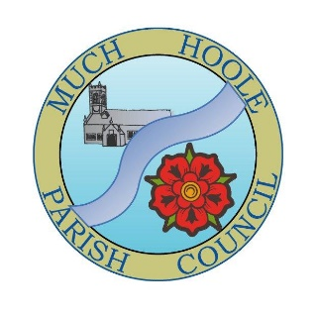 | MUCH HOOLE PARISH COUNCIL  NOTICE OF MEETING
 | You are hereby summoned to attend the Meeting of Much Hoole Parish Council to be held at 7.30pm on Monday 4th March 2024. The meeting will be held at The Venue (Hoole Village Memorial Hall) on Liverpool Old Road, PR4 4QA.
AGENDA
1. | Apologies for Absence  To receive apologies for absence from Cllrs N Woodcock, P Cocker and R Lea.
2. | Declaration of Interests and Dispensations  - To receive declarations of interest from Councillors on items on the agenda  - To receive written requests for dispensations for disclosable pecuniary interests (if any)  - To grant any requests for dispensation as appropriate.
3. | Minutes of the Previous Meetings  To vote on a resolution to approve the minutes of the Council meeting held on 5th February 2024 as being true and accurate.
4. | Public Time  To invite and listen to issues raised by members of the public.
5. | Correspondence from members of the public  To discuss correspondence received from members of the public
6. | Reports from other meetings and information on Future Events  The Council will receive reports from meetings where Councilors have attended as representatives and to discuss upcoming events that Councilors will be attending as representatives.
7. | Village Hall  - To receive and note a report on the progress of The Village Hall.  - To discuss and vote on a resolution to approve a Grant Application from Hoole Village Memorial Hall for £8,500 to convert the grass verge on the left of the road down to the back of the site plus other areas into hard standing. The initial cost to complete the road only is £6,960.
8. | Off Road Cycle Track  - To consider any updates on the Cycle track and resolve any actions required.  - To consider revised estimates from C Hewitt in respect of track maintenance and improvement.
9. | Finance  To resolve and authorise payment of the following;  - To review progress in respect of the setting up of Councillors who can authorise payments at the bank to also be able to initiate such payments.
10. | Grant application  None others received.
11. | Parish Clerk and Financial Officer  - To resolve to adopt the revised circulated contract of employment for the Clerk/Financial Officer.  - To review the results of interviews and to agree the next steps.  - To appoint a manager from the Councilor team for the Clerk/Financial Officer.
12. | Lengthsman  - To discuss the circulated Job List, Contract, Public Indemnity insurance and Risk Assessment aspects relating to the potential Lengthsman and agree the next steps.
13. | Review and adoption of policies – Standing Orders and Financial Regulations  To discuss any further amendments needed to these two circulated documents and, after agreement, to reaffirm their adoption by the Council and authorise them being posted on the Council website.
14. | Footpaths & Gardens  - To receive an update on the maintenance of footpaths FP11,12, 14, 17 and 18.  - To receive an update on the erection of the six footpath finger signs.  - To discuss progress on discussions with South Ribble Borough Council in respect of flooding, fruit trees and a live Christmas tree at the Trafalgar Garden.
15. | Planning  To review applications as follows:
16. | List of Events to Approve  Agree list of events circulated and approve signage costing.
17. | Items for next agenda
18. | Date of Next Meeting  The Parish Council to agree the date of the next meeting as 7.30pm Monday 8th April 2024 to be held at ‘The Venue’, Liverpool Old Road, Much Hoole.

